USER MANUAL
Group 77
Authors:
Raiyan Alam, Denis Gitman, Neel Patkar, Harman Singh, Namit Singh, Arshdip Singh

Contents
1. Login / Registration 2
2. Dashboard 3
3. Search and Filter Courses 3
4. Grade Tracker 4
5. View Course Stats 6
6. Viewing a Leaderboard 6
7. Earning Badges for Completing Courses 9
8. Flashcard maker 12

1. Login / Registration
Overview: Access the platform by creating an account or logging in.
Steps to Use:
- Click on ‘Login’ if you have an account or ‘Register’ to create one.
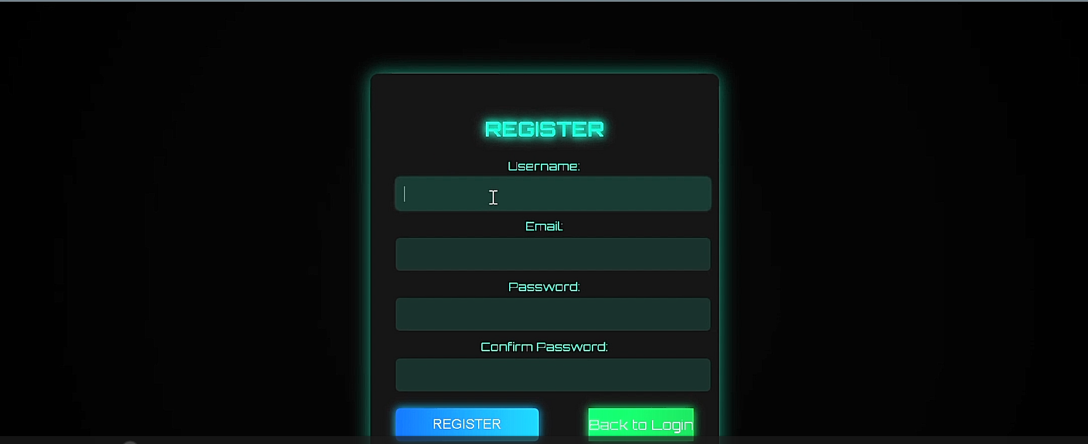
- Enter your email and password.
- Follow the instructions to verify your account.
- After verification, log in to access your dashboard.
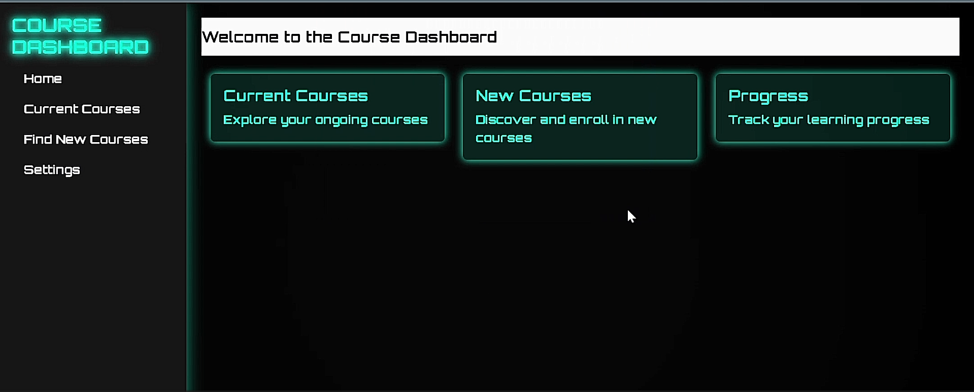

2. Dashboard
Overview: Your central hub for tracking course activity.
Steps to Use:
- Access the dashboard from the main menu.

- View enrolled courses, progress, and notifications.
- Click on any item for more details.

3. Search and Filter Courses
Overview: Quickly find courses based on specific criteria.
Steps to Use:
- User can either search for course name using keywords or categories
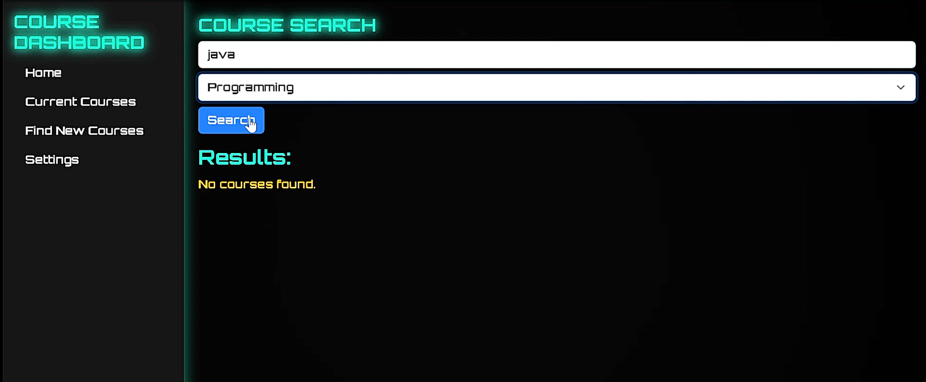
- Click the search button to find the course name
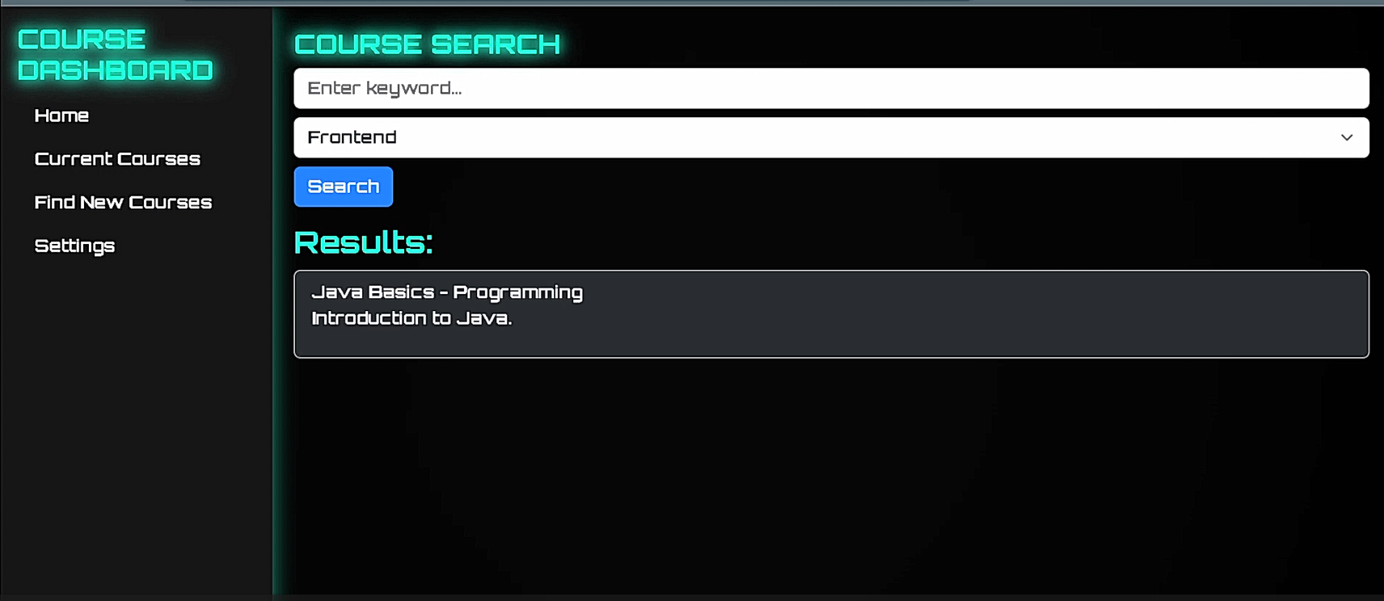
- The results are displayed

4. Grade Tracker
Overview: Monitor your grades and track progress.
Steps to Use:
- User enters course name and weight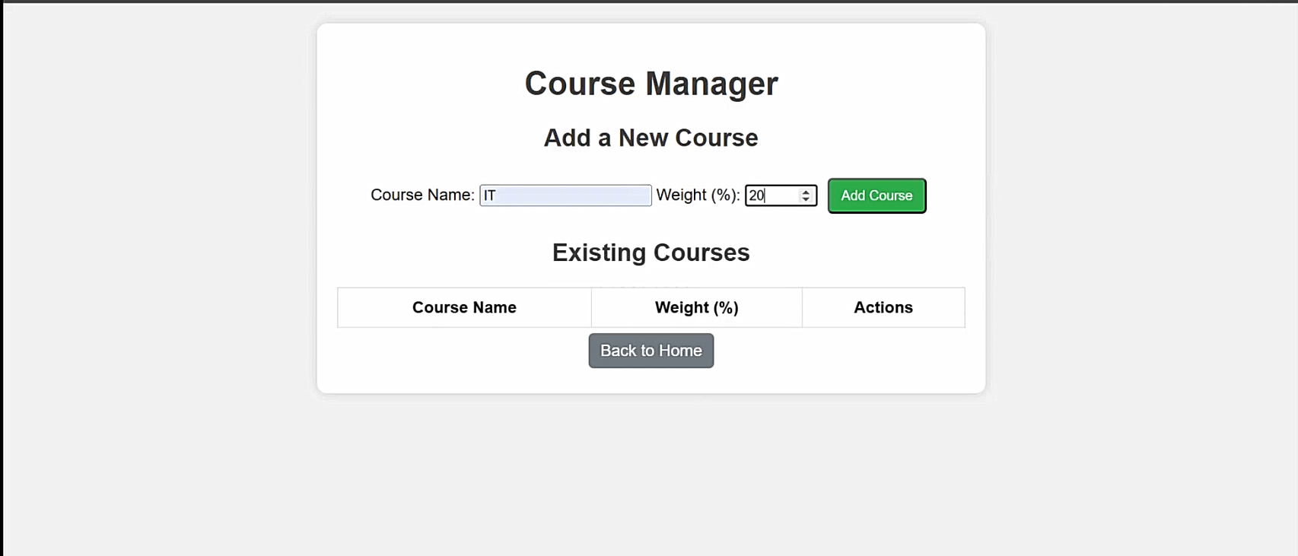
- User clicks the add course button to add the course to the course manager
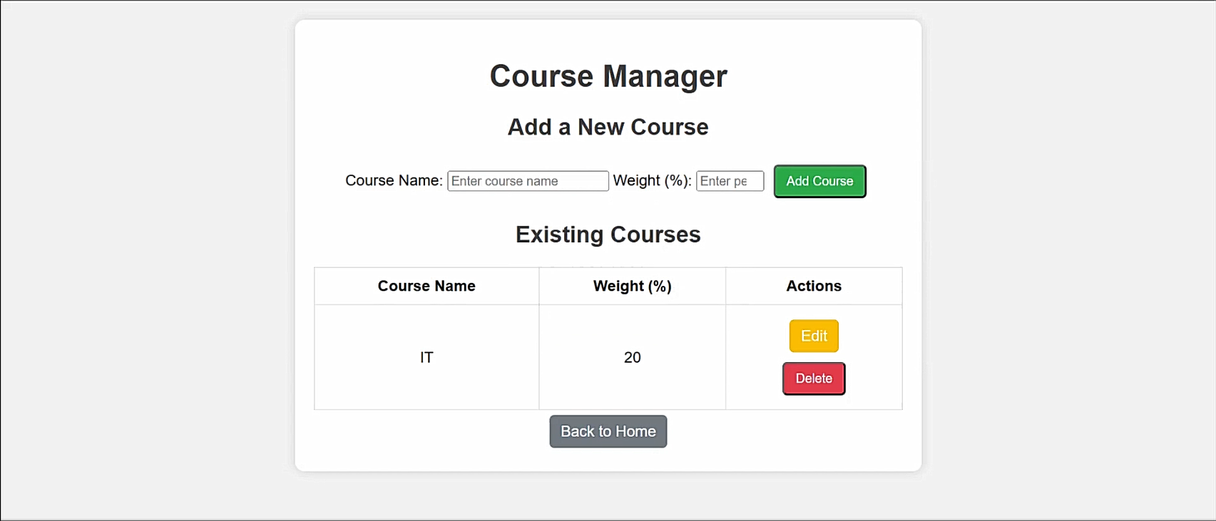
- User clicks on edit course and enters the edit course menu`
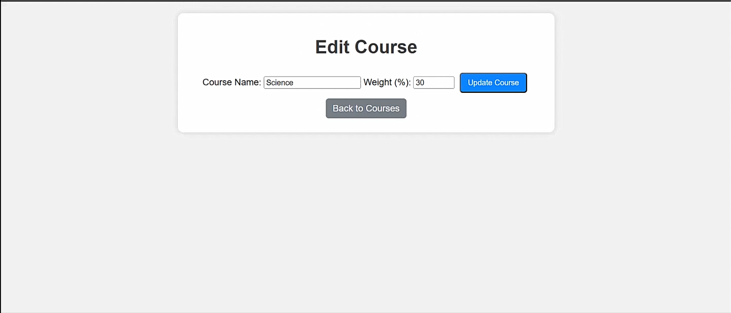

5. View Course Stats
Overview: Analyse course performance metrics.
Steps to Use:
- Go to ‘Course Stats’.
- View completed courses, active courses and total study time.
- Use insights to improve your learning approach.
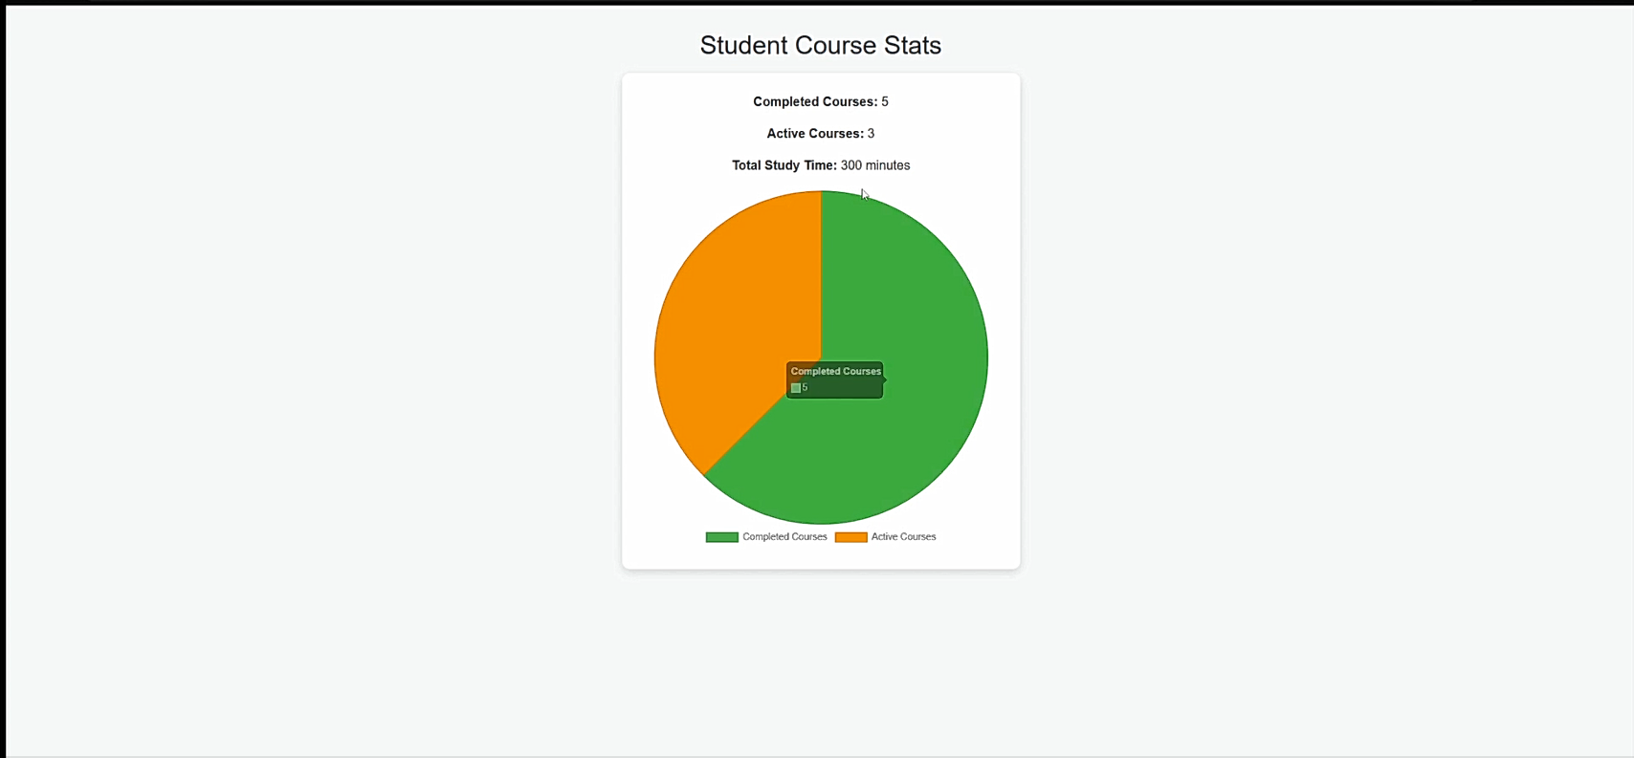

6. Viewing a Leaderboard
Overview
The Student XP Leaderboard is a Java Swing-based desktop application that displays a leaderboard of students ranked by their Experience Points (XP). The data is fetched from a MySQL database and presented in a user-friendly graphical interface. The application supports pagination, refreshing, and viewing detailed information about each student.

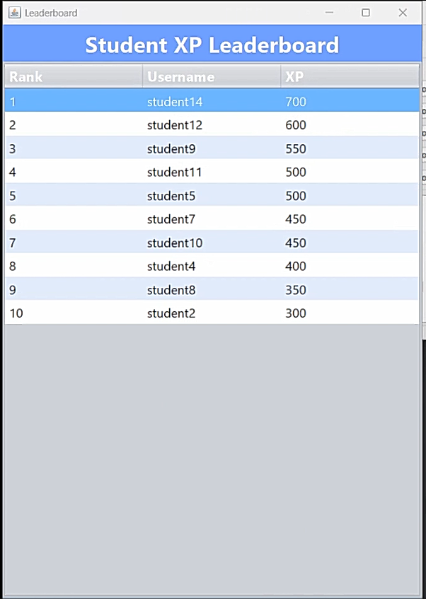
Key Features
Dynamic Leaderboard Display :
  - Displays students' rankings, usernames, and XP scores in a table.
  - Data is fetched dynamically from a MySQL database.
Pagination :
  - Supports navigation between pages using "Previous" and "Next" buttons.
  - Each page shows up to 10 students (configurable).
Refresh Button :
  - Reloads the latest data from the database to reflect any updates.
Row Details :
  - Clicking on a row in the table displays a popup with the selected student's username and XP.
Styling :
  - Alternating row colours for better readability.

The application has three main sections:
Header Panel
Displays the title: "Student XP Leaderboard" .
Provides a clean and professional look with a blue background.
Table
Shows the leaderboard with the following columns:
Rank : The student's position based on XP.
Username : The name of the student.
XP : The student's experience points.
Rows are styled with alternating colours (light blue and white) for readability.
Buttons
Located at the bottom of the window:
Previous : Navigate to the previous page of students.
Next : Navigate to the next page of students.
Refresh : Reload the data from the database to reflect any changes.

View Student Details :
Click on any row in the table to see a popup with the selected student's username and XP.
Navigate Pages :
Use the Previous and Next buttons to move between pages if there are more than 10 students.
Refresh Data :
If new students are added to the database or XP values are updated, click the Refresh button to reload the latest data.

7. Earning Badges for Completing Courses
Overview: Earn achievement badges when you complete a course.
Steps to Use:
- User enters the course ID they have completed
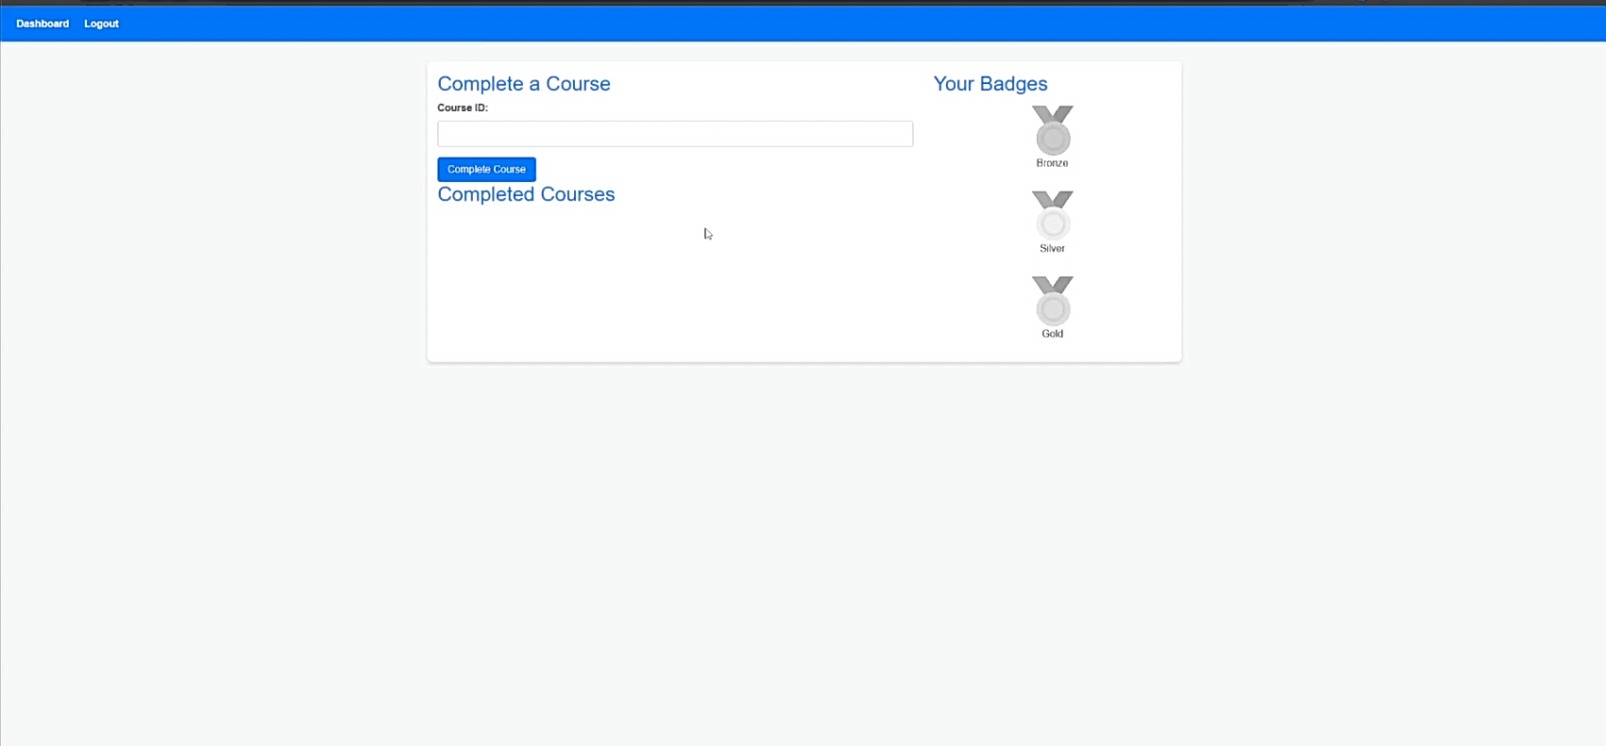
- User clicks on complete course
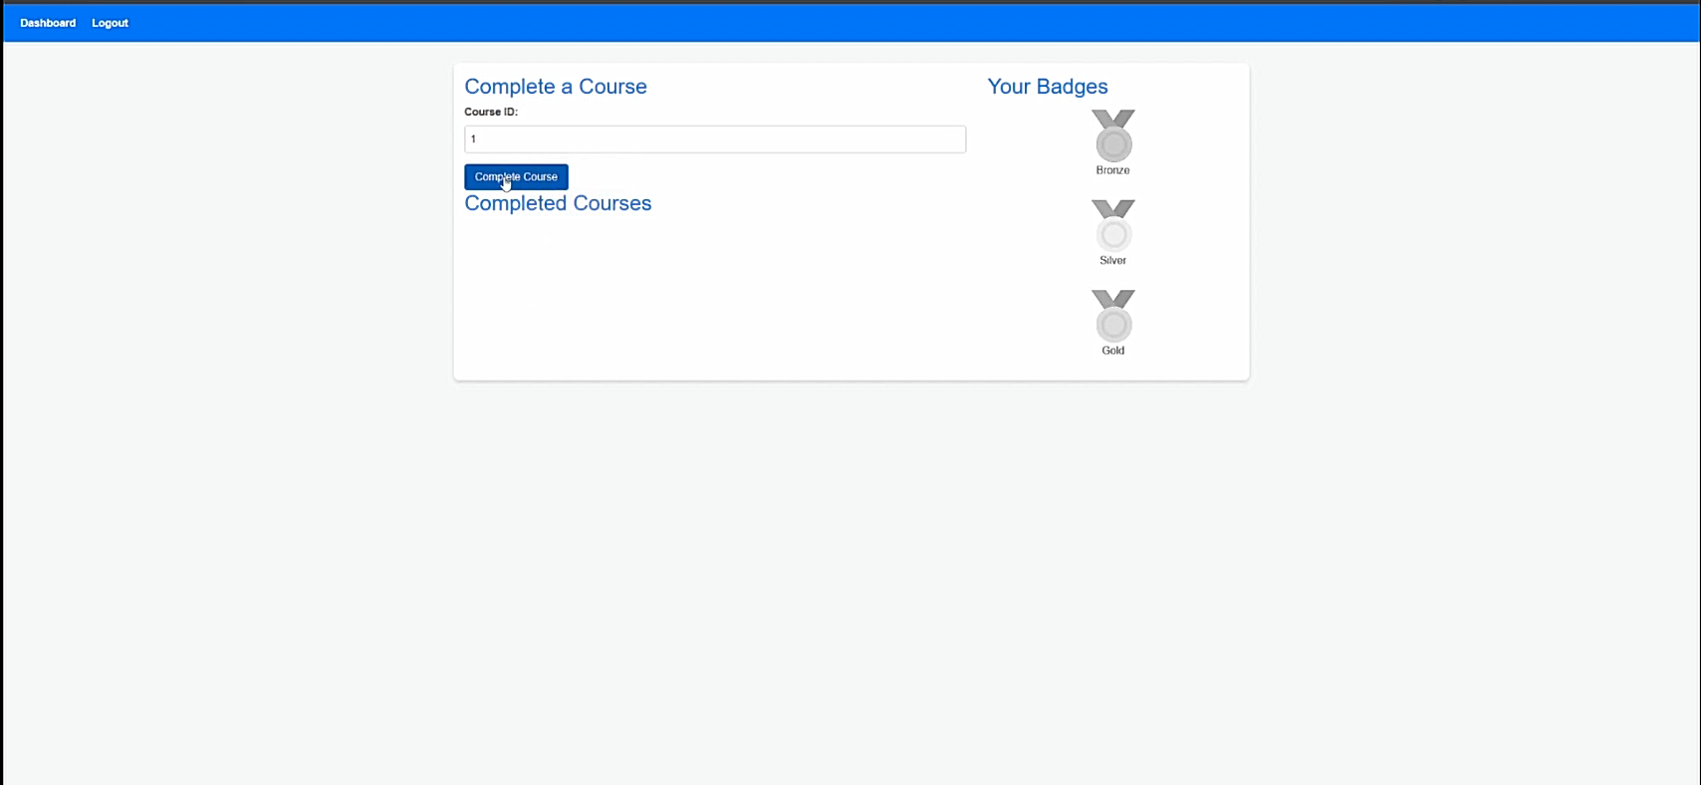
- Course is marked as completed
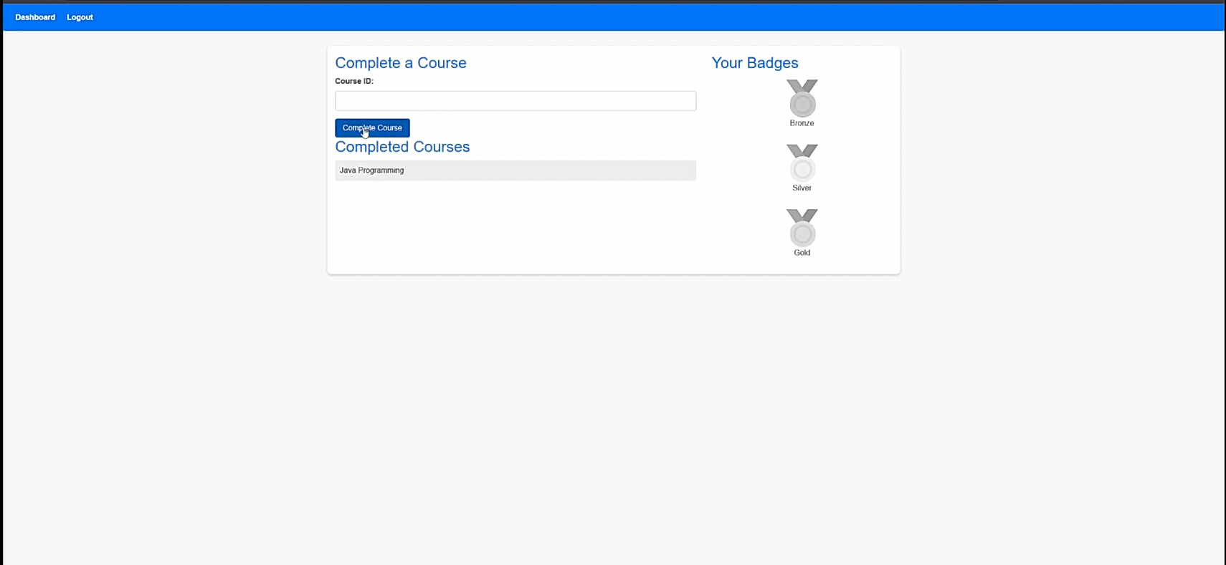
- After 5 courses have been marked as completed, the bronze badge will be awarded
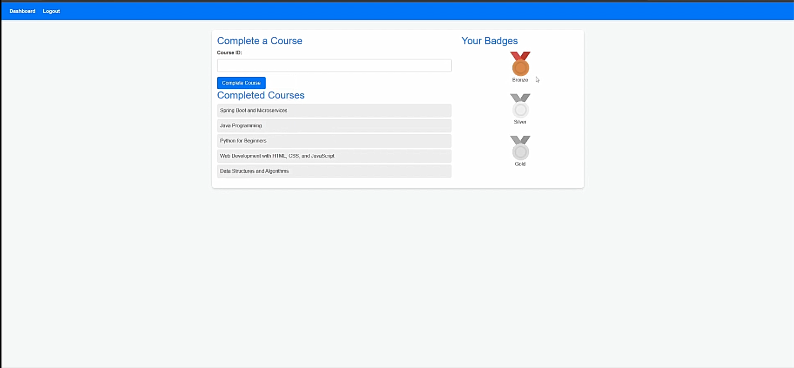
- After 10 courses have been marked as completed, the silver badge will be awarded
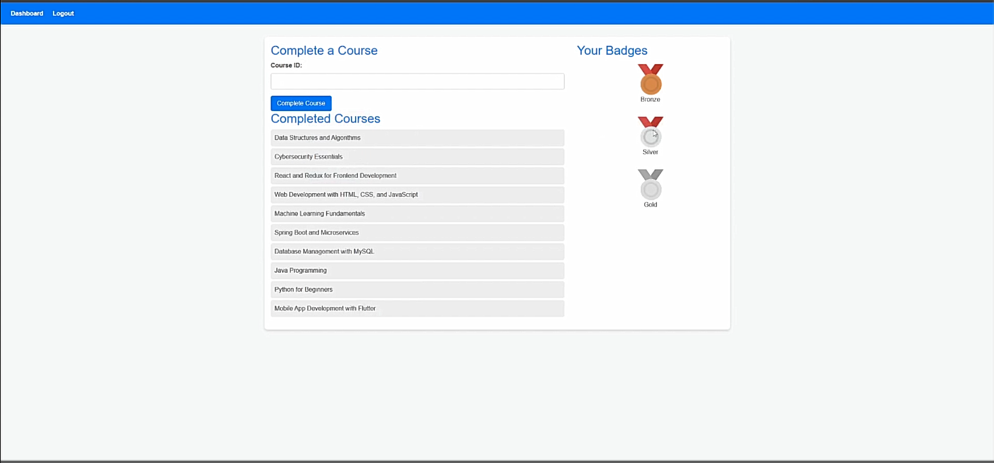
- After 20 courses have been marked as completed, the gold badge will be awarded
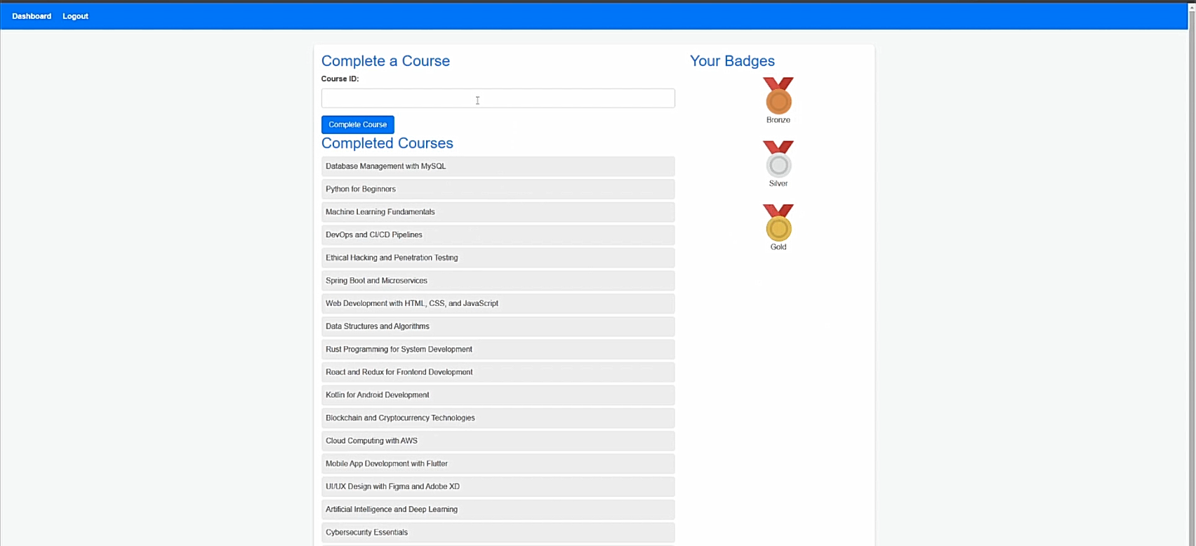

End of User Manual

